Art Informel

The French term informel was used by the critic Michel Tapié in order to describe a new trend in postwar abstract art displayed at two Paris exhibitions in 1951. The first exhibition, held in March at Galerie Nina Dausset, brought together works by artists such as Hans Hartung, Jean-Paul Riopelle, Georges Mathieu, Camille Bryen, Jackson Pollock, Willem de Kooning, and Wols under the theme of “extreme tendencies in non-figurative painting.” In his preface to the catalogue of this exhibition, Tapié connected the informel, or unformed, with the raw material anarchy of the real. The second exhibition, entitled “Signs of the Unformed,” was organized by Tapié in November at Studio Fracchetti, and included works by Jean Fautrier, Henri Michaux, Jean Dubuffet, Iaroslav Serpan, Jean-Paul Riopelle, and Georges Mathieu. The concept of the informel was theorised at length the following year in Tapié’s book Un art autre (usually but not unproblematically translated as Art of Another Kind). In this book, Tapié argued that art is “other” to the extent that it opens itself up to the unformed real in a way that radically breaks with the trajectory of modernist abstraction in terms of motivation, technique, and style.

Resonating with the somber mood of the postwar period — in which, according to Theodore Adorno’s famous assertion, it was increasingly difficult to create works of art — Tapié wrote that the artist must now face the abyss of the real in an almost mystical pursuit. Invoking both Friedrich Nietzsche and St. John of the Cross, Tapié argued that the postwar artist must create not beautiful or pleasurable objects, but must first of all plunge the depths of the self and of the world without the aid of any philosophical or religious supports. That is, borrowing the title of the March 1951 exhibition, the informel artist must “confront vehemence.” Tapié’s view of the postwar artist paralleled Jean-Paul Sartre’s writings on art and existentialism a few years earlier (in which, incidentally, Sartre praised Wols as being the existentialist artist par excellence): both believed there were no aesthetic values that could be determined a priori. Rather, such values, if any, could only arise in the act of creating a work. Tapié strongly preferred the term art autre over Art Informel, since, for him, the unformed referred primarily to the anarchic depths of the real rather than the abstract workings on a canvas. He even claimed that “art informel” was an absurd formulation and that there could never be, properly speaking, an Art Informel. Because neither term was rigorously defined, aesthetically or stylistically, and thus remained somewhat ambiguous (even by the time Jean Paulhan published his book L’Art Informel in 1962) art autre and Art Informel became largely indistinguishable and the later, being more linguistically flexible, ultimately became the preferred term in the literature. It is notable that many of the artists associated with either of these terms, including Fautrier, Michaux, and Dubuffet, found both of them — along with Tapié’s desire to herd together such deeply individualistic and diverse artists — highly deplorable.

Despite Tapié’s own particular differentiation between the appellations art autre and Art Informel, and despite their subsequent conflation by some, the terms have also come to loosely describe two overlapping aspects of postwar European art. Other critics have used the name Art Informel as a subset of art autre, which in this sense is a broader term that includes both figurative artworks, for example that of Dubuffet, and abstract or calligraphic ones, like that of Mathieu and Michaux. Making matters even more convoluted, this abstract tendency has been referred to not only as Art Informel, but also as Tachism(e) and lyrical abstraction. Here Art Informel should be understood not as radically formless but rather as expressing a gestural, spontaneous, and anti-geometrical type of abstraction that conveys a coming-to-form. In this sense, it has been uncritically described as the weak European counterpart of abstract expressionism (albeit on a more intimate scale by comparison) even though it is widely acknowledged that the two groups of artists seem to have developed more or less independently out of surrealist automatism. However, this comparison is partly justified, since Mathieu’s delicately gestural works were often performed before an audience by squeezing or dripping paint directly from the tube, and since Fautrier’s heavily impastoed and much more somber works were often produced flat on the floor.

Ultimately, in talking about either art autre or Art Informel, the thing that loosely unites the artists Tapié brought together in 1951 is a postwar existential angst and disgust, which manifests itself stylistically in the vehement refusal to engage with beautiful forms. Instead, half-formed images appear in their very emergence within a web of gestures or within a thick accumulation of matter as if capturing the moment of the artist’s encounter with both the abyss of the real (as Tapié called it) and the space of the canvas. Art Informel, while not a coherent movement, is significant because it disallows the normative and unidirectional view of art history that transports us directly from Paris to New York following the Second World War. From 1960, for example, Tapié helped to foster Art Informel — as well as associated groups such as spatialism and nuclearism — in Italy by co-founding the International Centre of Aesthetic Research in Turin. Tapié also had a significant impact upon the development of the Gutai artists in Japan (who would, in turn, affect other important contemporary tendencies like Fluxus and Happenings) by visiting there in 1957 and 1958 in order to disseminate his ideas concerning art autre and art informel.

Jay Hetrick

References and further reading

Carter, Curtis and Karen Butler, eds., Jean Fautrier (New Haven: Yale University Press, 2002)

Haftmann, Werner, ed., Wols (New York: Harry Abrams, 1965)

Marter, Joan, ed., Abstract Expressionism: The International Context (New Brunswick: Rutgers University Press, 2007)

Morris, Frances, ed., Paris Post War: Art and Existentialism 1945-55 (London: Tate, 1994)

Schimmel, Paul, ed., Destroy the Picture: Painting the Void, 1949-1962 (New York: Skira Rizzoli, 2012)

Tapié, Michel, ‘A New Beyond’ in Herschel Chipp, ed., Theories of Modern Art (Berkeley: University of California Press, 1968), pp. 603-605

Tapié, Michel, The Significant Message of Georges Mathieu (New York: Stable Gallery, 1952)

Suggested images

Wols, Bird, 1949, oil on canvas, 92 x 64 cm. Menil Collection, Houston
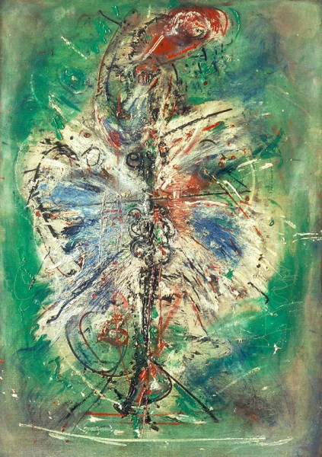

Jean Fautrier, Head of a Hostage no. 14, 1944, mixed media on paper, 35 x 27 cm. Museum of Contemporary Art, Los Angeles

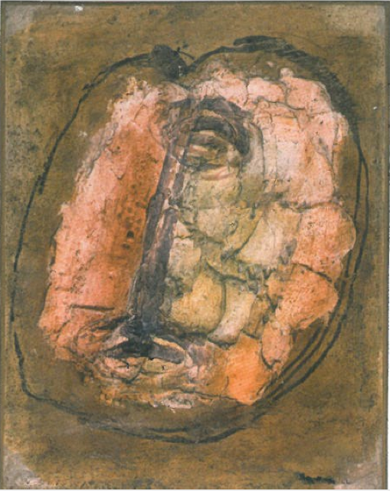

Georges Mathieu, Painting, 1952, oil on canvas, 200 x 300 cm. Solomon Guggenheim Museum, New York

